**ESS Tuning Dump Screen System**

**Pump down Checklist**

**Document Change Record**

|  |  |  |  |
| --- | --- | --- | --- |
| Version | Date | Section/Sheet | Comment |
| 1.0 | 18/10/19 |  | First Issue |

**Document Purpose**

This document defines the checks required for pumping down the ESS tuning dump assemblies. This document should be printed and completed by hand during assembly. This is necessary to ensure maximum pump down rates and cleanliness is maintained.

This document should be printed and completed by hand during assembly. Once completed with all signatures, a scanned copy should be sent to the project manager for storage in the document management system.

**Unit**

|  |  |
| --- | --- |
| Module Name: |  |

**Approval**

|  |  |  |  |
| --- | --- | --- | --- |
| Assembled by: | Print | Signature | Date |
| Approved by: | Print | Signature | Date |

**Test Procedure**

The figure below shows a schematic of the pumping trolley that shall be used to pump down the ESS Tuning Dump assemblies. Operation of this equipment will be performed manually and before it can be operated any user must be supervised by an approved member of staff.

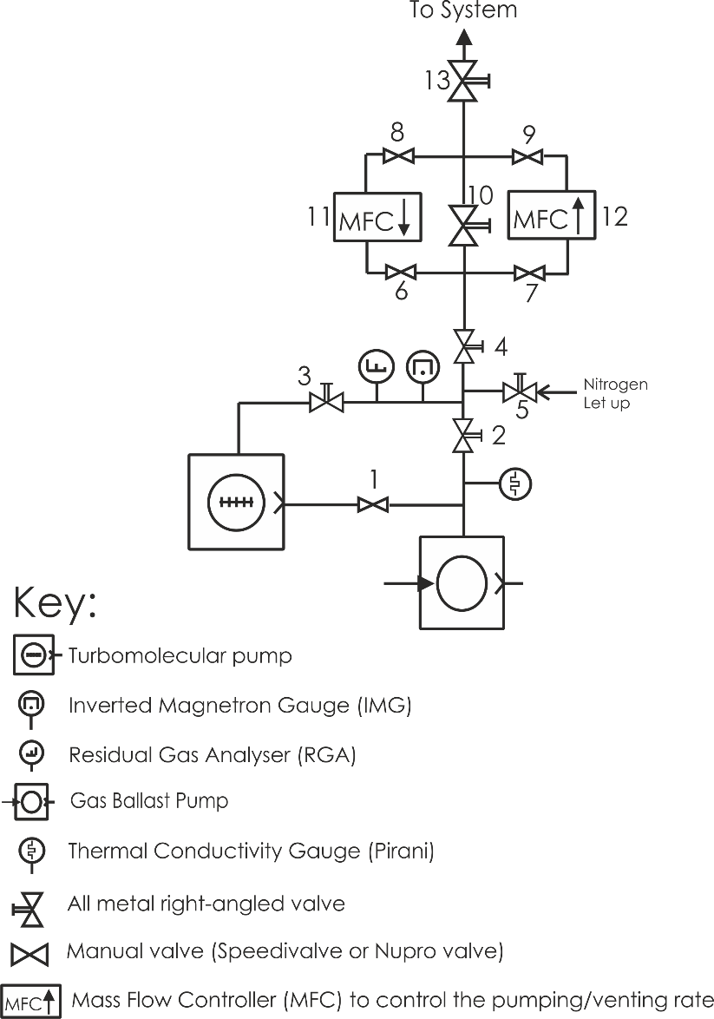

Figure 1 Schematic of LWU Pumping Trolley

The most critical concern with the pump down or venting of the ESS Tuning Dump Vessel is the control of the Mass Flow Controllers (MFC) as shown in Figure 1 (part number 11 for pump down and 12 for venting). These mass flow controllers allow accurate control of the pump down rate. This is a crucial process when evacuating the ESS Tuning Dump Vessel as there is a requirement to avoid turbulence and minimise the movement of residual particles inside the vacuum envelope. This can only be achieved with a pump down rate of **LESS THAN 20 MBAR PER MINUTE.**

|  |  |  |
| --- | --- | --- |
| **Step number** | **Task Description** | **Initial / Date** |
|  | Before starting ensure valves 1, 3, 4, 6, 7, 8, 9 & 10 on the system are in the **OPEN** position.  Also ensure valves 2, 5 & 13 are in the **CLOSED** position |  |
|  | Switch on the scroll pump manually (gas ballast pump in figure 1) |  |
|  | Allow the scroll pump to evacuate the pumping trolley and monitor the pressure using the Pirani gauge until it reaches a pressure of  **1 x 10-1 mbar**. |  |
|  | Once a pressure of **1 x 10-1 mba**r has been achieved, switch on the turbo molecular pump and allow it to reach full speed. |  |
|  | Monitor the pressure of the pumping trolley using the inverted magnetron gauge.  Once the inverted magnetron gauge reaches a pressure of **5 x 10‑6 mbar** then switch on the RGA filament and leave it on for a minimum of 15 minutes. |  |
|  | Once the RGA filament has been on for 15 minutes an RGA scan of the pumping trolley will be taken and analysed to ensure it complies with the ASTeC specification (ASTEC VAC QCD spc 005 - Acceptance tests for Vacuum Vessels, Components and Assemblies)  If the RGA scan complies with the ASTeC specification we can be sure the pumping trolley is in a good ‘clean’ condition and it is safe to proceed to the next step. |  |
|  | Switch off the RGA filament. |  |
|  | Switch off the turbo molecular pump and **allow 15 minutes** for the turbo molecular pump to slow down. After 15 minutes switch off the scroll pump as well (gas ballast pump in Figure 1). |  |
|  | Using dry nitrogen vent the pumping trolley to atmospheric pressure through valve number 5 in Figure 1. |  |
|  | Now the system is ready to perform the controlled pump down:  Ensure valves 1, 3, 4, 6, 7, 8, 9 & 13 on the system are in the **OPEN** position.  Also ensure valves 2, 5 & 10 are in the **CLOSED** position |  |
|  | Switch on the scroll pump manually (gas ballast pump in Figure 1).  **Connect to the MFC labelled 11 in Figure 1.**  **Set the flow rate accordingly (typically 400 sccm) to ENSURE A PUMPDOWN RATE OF < 20 MBAR PER MINUTE WILL BE ACHIEVED.** |  |
|  | Monitor the pressure using the Pirani gauge on the pumping trolley and the Pirani gauge on the LWU until they **BOTH** reach a pressure of **< 1 mbar** (this could take up to 2 hours). |  |
|  | Once both pirani gauges are below 1 mbar **CLOSE** the MFC labelled 11 in Figure 1.  **Now open valve 10** |  |
|  | When a pressure of **1 x 10-1 mbar** has been achieved on both pirani gauges switch on the turbo molecular pump and allow it to reach full speed. |  |
|  | Switch on both inverted magnetron gauges (one on the pumping trolley and one on the LWU)  Monitor the pressure of the system using the inverted magnetron gauges on the pumping trolley and the LWU beam pipe.  Once **BOTH** the inverted magnetron gauges reach a pressure of **5 x 10‑6 mbar** then switch on the RGA filament and leave it on for a minimum of 15 minutes. |  |
|  | Once the RGA filament has been on for 15 minutes an RGA scan of the complete system (pumping trolley + LWU) will be taken and analysed to ensure it complies with the ASTeC specification.  If the RGA scan complies with the ASTeC specification we can be sure the LWU or beam pipe is in a good ‘clean’ condition. |  |
|  | Once the pressure on **BOTH** inverted magnetron gauges is **< 5 x 10‑6 mbar** then the Sputter Ion Pump (SIP) part of the NEXTorr pump shall be switched on to ensure it is working.  If the gauges and SIP are working then **SWITCH THEM OFF**  Once SIP and gauges are off then we are ready to perform a controlled vent. |  |
|  | Switch off the turbo molecular pump and **allow 15 minutes** for the turbo molecular pump to slow down.  **CLOSE VALVES 1 & 2** |  |
|  | Carefully **CLOSE** valve number 10 and **OPEN** valve number 5  **Connect to the MFC labelled 12 in Figure 1.**  **Set the flow rate accordingly (typically 400 sccm) to ENSURE A VENTING RATE OF < 20 MBAR PER MINUTE WILL BE ACHIEVED.** |  |
|  | Vent to a pressure of 1050 – 1100 mbar as measured on the LWU.  **CLOSE** the MFC labelled 12 in Figure 1.  **SWITCH OFF SCROLL PUMP**  **OPEN VALVE 2**, vent scroll pump and backing line to atmospheric pressure.  **CLOSE** valve number 5 |  |

**Continuation Sheet:**

|  |
| --- |
| *Record any additional observations here* |